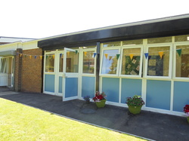
ACE Newsletter 
Welcome to our summer newsletter to fill you in on the activities which have taken place at ACE. What a busy term we have had. Our external examinations began after Easter and have now finished. The students were fantastic, attending extra revision classes to support their learning and using relaxation techniques before each exam, supported by Clare our CAMHS support worker. We had our Y11 leaver’s celebration on the 21st of June which was an extremely entertaining night, full of fun. The staff entertained all with their line dancing skills in full cowboy attire, a lasting memory for everyone!
It is always sad to say goodbye but we wish them every success as they embark on the next chapter of their lives and we hope we have equipped them with the skills to succeed and embrace the challenges that lay ahead.

TRIPS This term, students have been involved with various days out

Slice Project- Our KS3 Students have had the opportunity of developing new skills in photography workshops at the Maritime museum. Their exhibition entitled ‘through my eyes’ was open to the public 7th-12th of July to celebrate their fantastic work- Well done.

-

.

Subjects

ENGLISH.
This half term KS3 students have been studying a well-known book called ‘Holes’ by Louis Sacher. The book covers a number of themes that our students can relate to and we will be studying lots of interesting elements based around the text. A great summer read and a book that everyone is enjoying!

This half term has seen our new KS4 students adjusting to their new classes and have started off with some new topics. The students have been experiencing some GCSE topics that will prepare them for the journey ahead and have all made an excellent productive start. Well done! Areas we have begun to study are; the Poems from the Anthology and Lord of the flies in Literature and writing for a purpose in Language.



Science
This term in Science Key stage 4 pupils have been learning how to plan an experiment to test a range of hypothesises. They also carried out multiple required practicals towards their GCSE Biology Examination and have just completed their end of year Biology mock examination to hopefully demonstrate the progress they have made. In key stage 3 we have been learning about the importance of food chains, webs, energy transfer and animal adaptations. WE have had a small investment in practical science equipment which will enhance their learning and enjoyment

We visited Quarry Bank Mill in Manchester on Tuesday where students had the opportunity to explore local history, the Industrial Revolution and discover what it was like to be a factory worker, seeing how cloth was made and how water and steam were used to drive machinery.

We are looking forward to our end of year trip to Blackpool Pleasure Beach. We are always looking for new ideas for trips so encourage your children to let us know where they would like to go and activities they would enjoy. Photos of day our will be on our website shortly

We have a summer fair planned for the last day of term that will involve lots of fun activities, stalls and even an assault course

Upcoming Events…

Attendance Summer Term 2018
Jacqui Mooney, Assistant Psychologist recently joined ACE in May 2018. Like Claire, Jacqui works for CAMHS and her role involves providing additional support for ACE students who attend CAMHS. Jacqui is based in ACE Mondays, Wednesday mornings and Fridays. Feel free to pop into the CAMHS
room and have a chat! ☺

A big thankyou to all staff, and pupils for their commitment and hard work this term. We finish for the summer holidays on Friday 20th July and will return on 11th September.

Y11 exam results will be available from 9:30
Best Wishes from
ACE Staff
Mark Hilton (Headteacher)
Wendy Henshaw (Head of ACE)
Lin Loughlin
Jessica Brady
Gary Berkley
Ross Crilly
Amanda Crilly
Lisa Duffy
Mark McCarthy
Lynne Anders
Jenny
Natalie Blunsom
Katy Blake
Rachel Christian
Claire Austin
Jaqui Mooney

Students achieved 100% attendance.
Well done , , and

Students achieved 90% and above attendance
students achieved 80% and above attendance

These attendance figures are a fantastic achievement for pupils at ACE. We will try our best to support pupils and parents so that attendance can continue to improve.

.


In order to help you to have a smooth and happy transition back to learning with ACE in September we would like to remind you of how we look and how at ease you know you can feel coming in to the school base for your lessons.
Remember we have 5 classrooms, a time-out room, a sensory room and access to the Art Room .
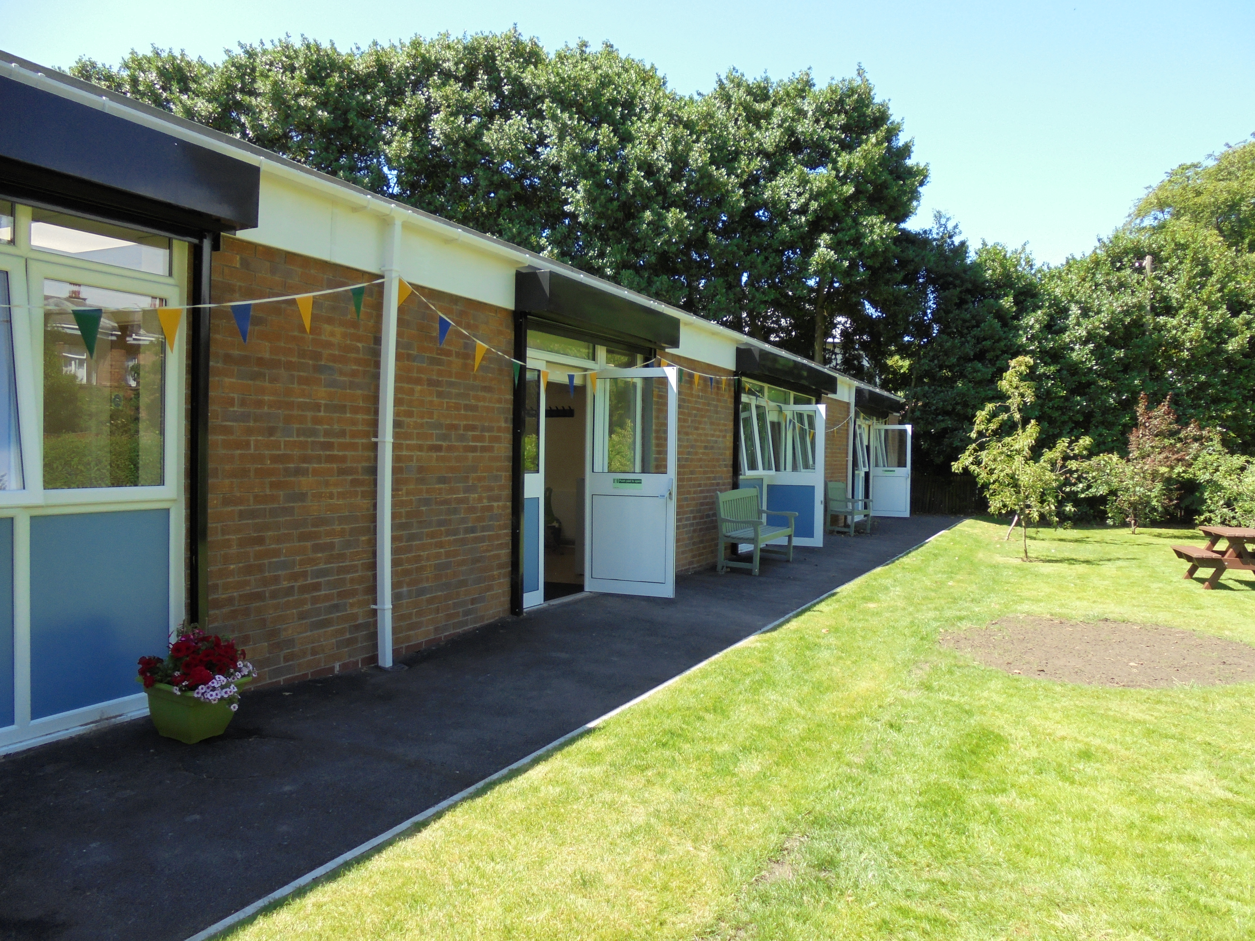

Try to ensure you are able to relax, meet friends and family and get out and about.
You might find a new interest or have time to pursue an existing one. You could set some days aside for ‘you time’. Pamper yourself, listen to your favourite music and chill out. It is important that you let your brain and your body relax so that you are refreshed for the new academic year in September.

The School Day:
There will be 5 lesson times per day.
There is a break between each lesson.
Lessons will only be 50 minutes long.
This should help with concentration and it means you will be able to have more frequent lessons in Maths, English, Science, History and French.

The School Day:
There will be 5/6 lesson times per day.
There is a break between each lesson.
Lessons will only be 50 minutes long.
This should help with concentration and it means you will be able to have more frequent lessons in Maths, English, Science, History and French.

PSE
Physical and Social Education
These lessons will give you the opportunity to have fun, be active and learn how to develop your social skills.
The activities on offer will be flexible so that everyone has the chance to take part.



