Virtual Learning at ACE
ACE

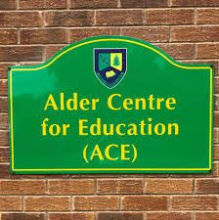

A Guide to Google Classroom for Pupils and Parents

PC / Laptop version
Logging into Google Classroom 1
Enrolling in classes 3
Accepting invitations 4
Completing Assignments set by Teachers 5
Managing Notifications 6
School Email from Home 7-8

Mobile / Tablet version
Logging into Google Classroom, Enrolling in classes and accepting invitations 9
Completing Assignments set by Teachers 10
Managing Notifications 11
School Email from Home 12

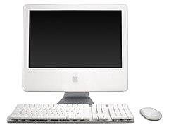
Logging into Google Classroom

DESKTOP VERSION

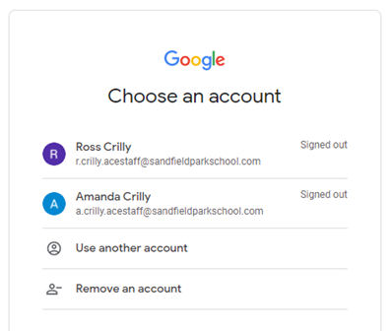
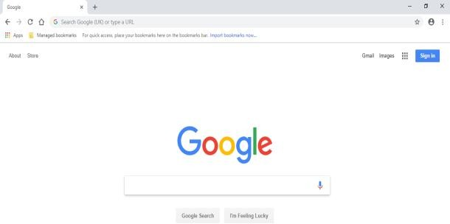
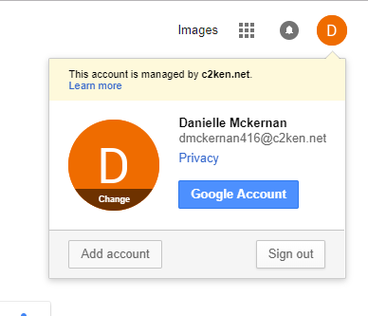
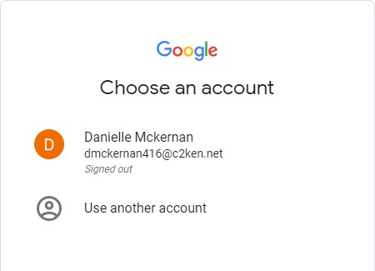
3. Click ‘sign in’. When you click ‘sign in’, the login screen will appear. You may see another account listed here if someone else in your family uses their google account on the device.

In this instance, click use another account
option.

Go to step 4
2. If there is an initial there instead of “sign
in”, it means someone else is already logged into Google on the device.

Click the initial and check the account.

If it is not your account, you need to either switch accounts by clicking your own from the list

or choose “Use another account”. Go to step 3
1. Go to the Google homepage. Look at the top right corner.
You will see either “sign in” or a “letter. If you see a “letter”, go to step 2.
If you see “sign in”, go to step 3.

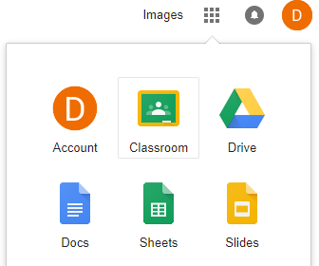
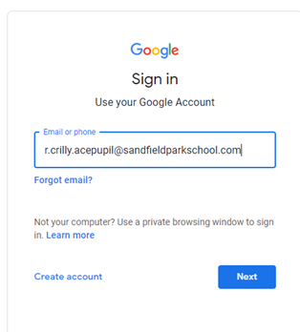
Use your school username and school password to login.

Add @sandfieldparkschool.com
to the end of your username

e.g r.crilly.acepupil@sandfieldparkschool.com

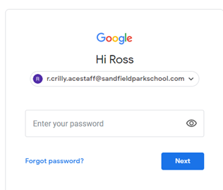

Click next

- Enter school password

Click next

7. You will now see a letter at the top right of your screen.

Click the “waffle/matrix” icon

and choose google classroom.

- Your classroom dashboard will appear. Any classes you have been invited to join will appear here. Click the join button on these classes.

If the dashboard is empty, it means you have not enrolled in any classes yet.

Enrolling in Classes in Google Classroom

DESKTOP VERSION

1. Log into google classroom (see previous section).  On your main screen you will see the class you have been invited to. Click this icon and choose join class. | 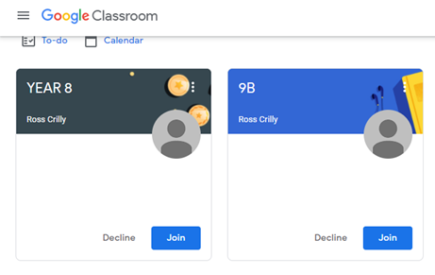
2. You may be prompted to enter a code, enter the code supplied by your teacher and click join.  It is unlikely you will need this code | 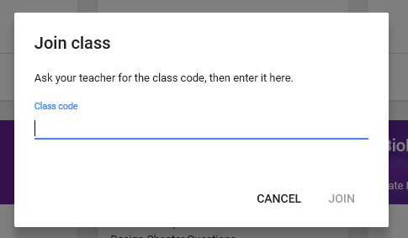
3. You will now see the classroom tile in your dashboard.  Click the class name to enter the class. | 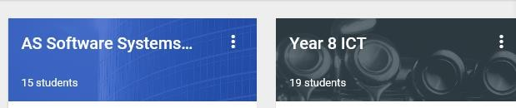  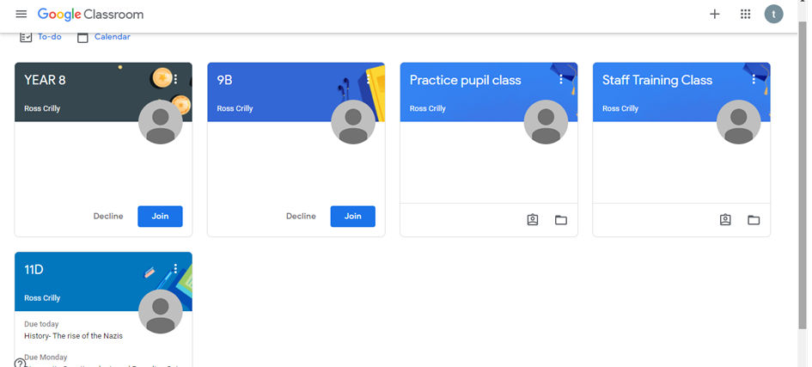

Accepting Classroom Invitations
DESKTOP VERSION

Log into google classroom (see previous section).

The Class you have been invited to appear with a join button.
Click the ‘join’. the device.
Troubleshooting:  If you are expecting an invitation and it has not appeared in the dashboard.  - Try refreshing your web browser  - Check you are logged in with the correct ACE Account. | 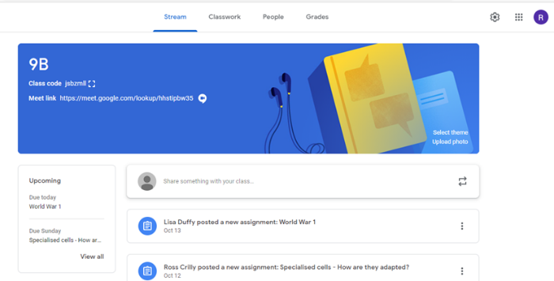

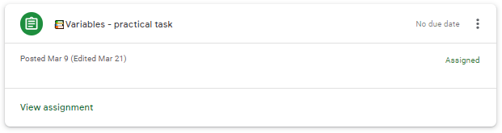
Completing Assignments set by Teachers
DESKTOP VERSION

1. Go to the main Google classroom dashboard, where your class can be seen.

Check the account is definitely your account
r.crilly.acepupil@sandfieldparkschool.com

Ross has an R
Your name will have your 1st Intial

You should only see the you are part of.

If this is not the case please let Ross know.
2. You will see options along the top.  Stream  - announcements are posted here and if the teacher permits, you can comment  Classwork  - Click here to see your assignments.  Upcoming  - Deadlines for work due  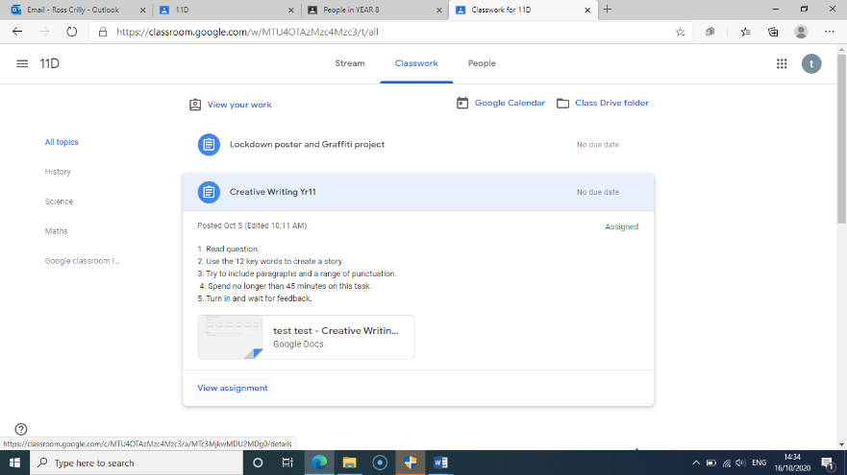  3. Click the classwork tab and click the assignment to be completed.  Click view assignment and read the task instructions carefully.  [Continued next page….] | 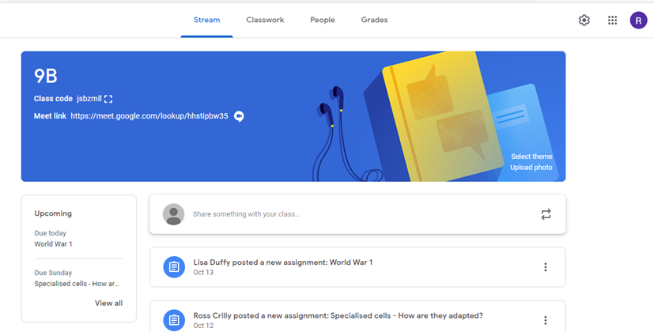
To open your task click on the attachment  This will open it in Google documents. | 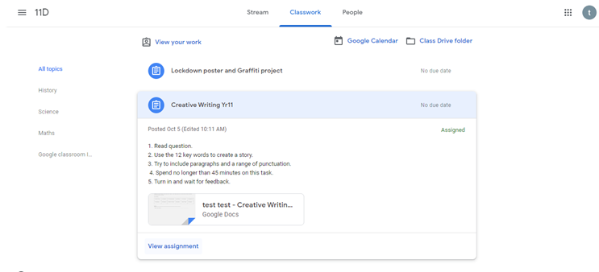

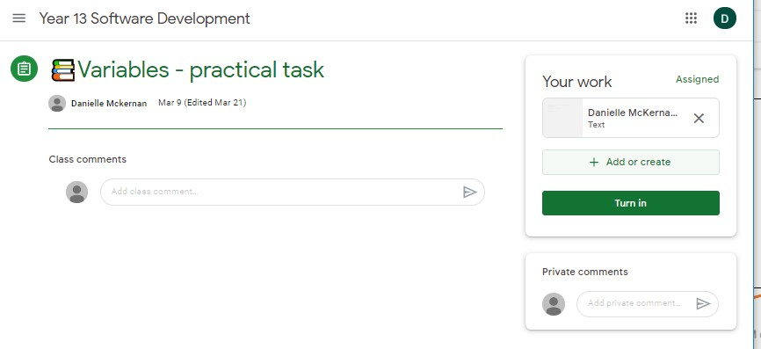
4. To return work to your teacher,

click the ‘add or create’ option.
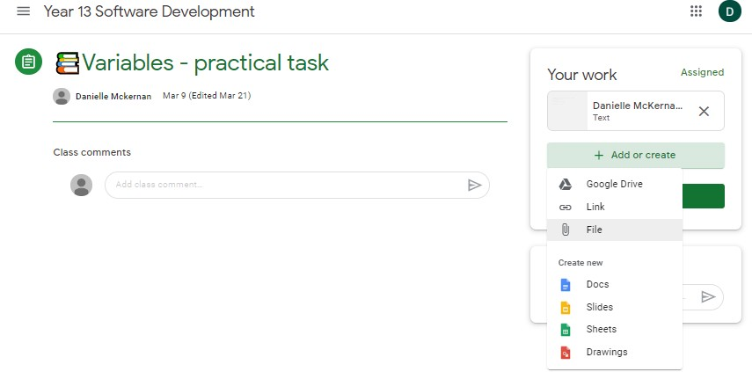
5. Choose the location of the file. If the file is on your computer, choose file upload.

If you need to send photos of your work, you will need to capture these first with your phone and then
- either upload to Google Drive or
- transfer to your computer.
- You could email the photos to yourself and then open on your computer. (It is much easier to upload photos using the mobile app. See the mobile instructions if you need to upload photos)
6. When you have attached your work, click “turn in”.

You can also add a private comment to your teacher.

If work is returned to you from your teacher, it will be available here and your teacher may also leave you a comment.

How to access your school email account?

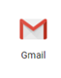
2.School email from a Tablet /Mobile device
Page 9
1.School email from a PC / web browser
Page 8
Teacher emails
Ross Crilly –Science /Google classroom issues
r.crilly.acestaff@sandfieldparkschool.com

Lisa Duffy- History
l.duffy.acestaff@sandfieldparkschool.com

Gary Berkley-English
g.berkley.acestaff@sandfieldparkschool.com

Clare Hassan-Maths
c.hassan.acestaff@sandfieldparkschool.com

Mark Mc Carthy -Maths
m.mccarthy.acestaff@sandfieldparkschool.com

Amanda Crilly-Home Tuition
a.crilly.acestaff@sandfieldparkschool.com

Julie Unsworth –Art / Home tuition
j.unsworth.acestaff@sandfieldparkschool.com

Jenny Kennedy –English / Home tuition
j.kennedy.acestaff@sandfieldparkschool.com

What emails can be used for:

- All work set by your teachers will generate an email to your Gmail account.
- You can use this to email your teacher any work that can’t be sent via Google Classroom.
- You can use this email to ask for support in school or make your teacher aware of any problems you have with Google Classroom or classwork.

Teacher Goggle classroom email addresses

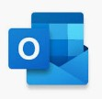
School Email from Home
DESKTOP VERSION

- Go to Google  - Click sign in  Login with school username and password | 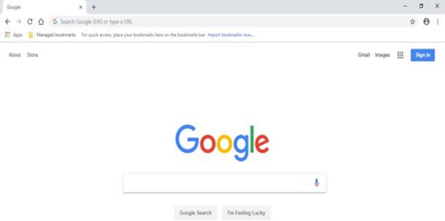
- Click on the Matrix box  - Click on the Gmail icon | 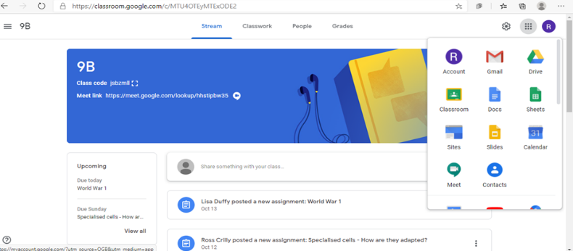
3. You may need to re-enter your ACE email  and password  And then click yes | 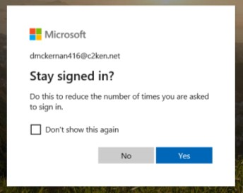
4.You should now see your emails.  - Here you can email your teachers directly if you have a problem. | 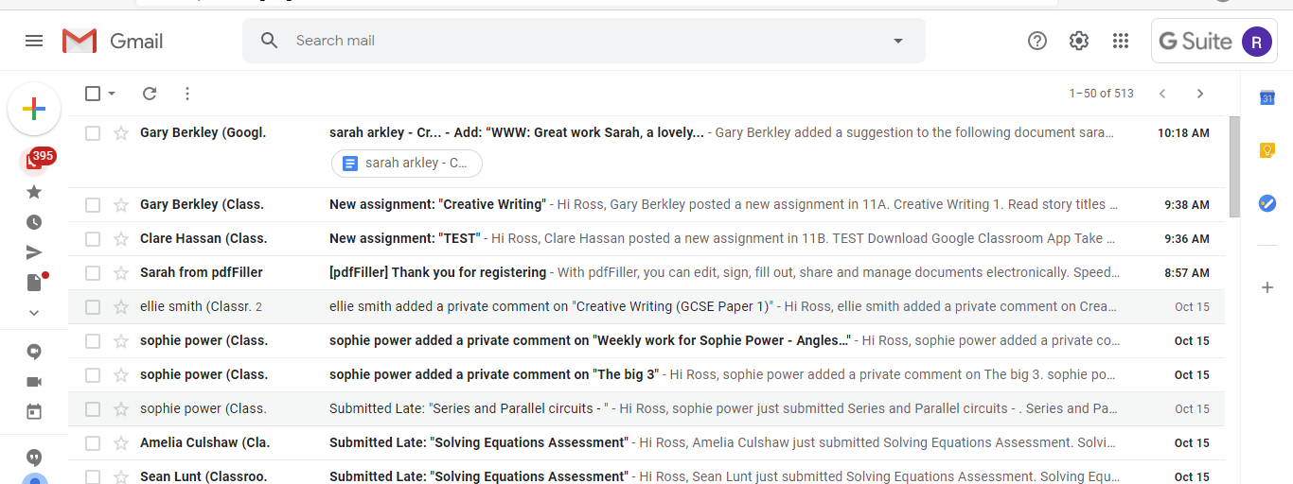

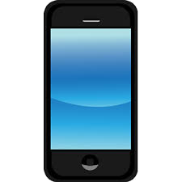
Logging into Google Classroom
Enrolling in classes & accepting invitations

MOBILE VERSION
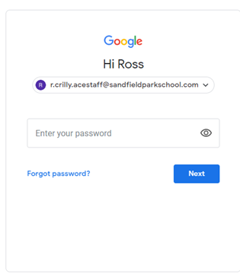
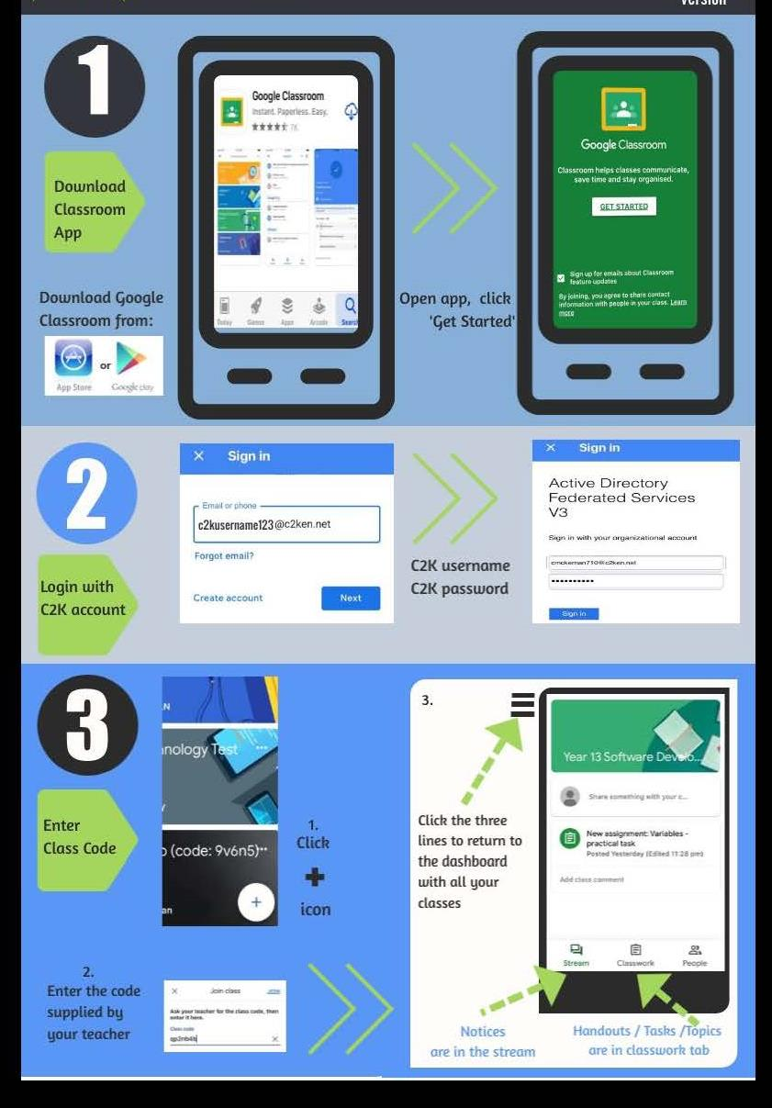
Click next
Click join class
Log in
ACE Account

You may also see subjects with a “join” button. These are invitations from your teacher. You do not need the code for these classes. Click “join” to accept

Completing Assignments set by Mobile
MOBILE VERSION

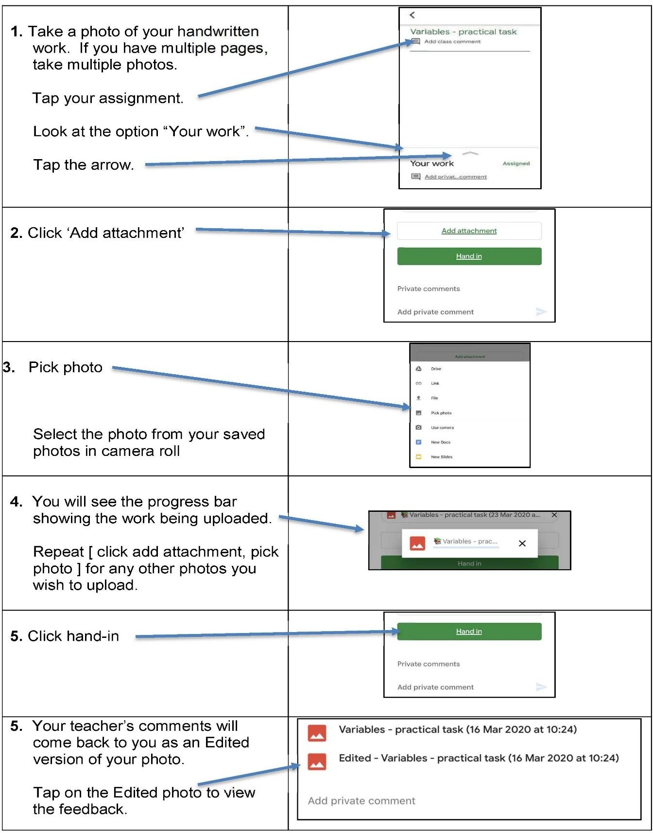

Managing Notifications
MOBILE VERSION

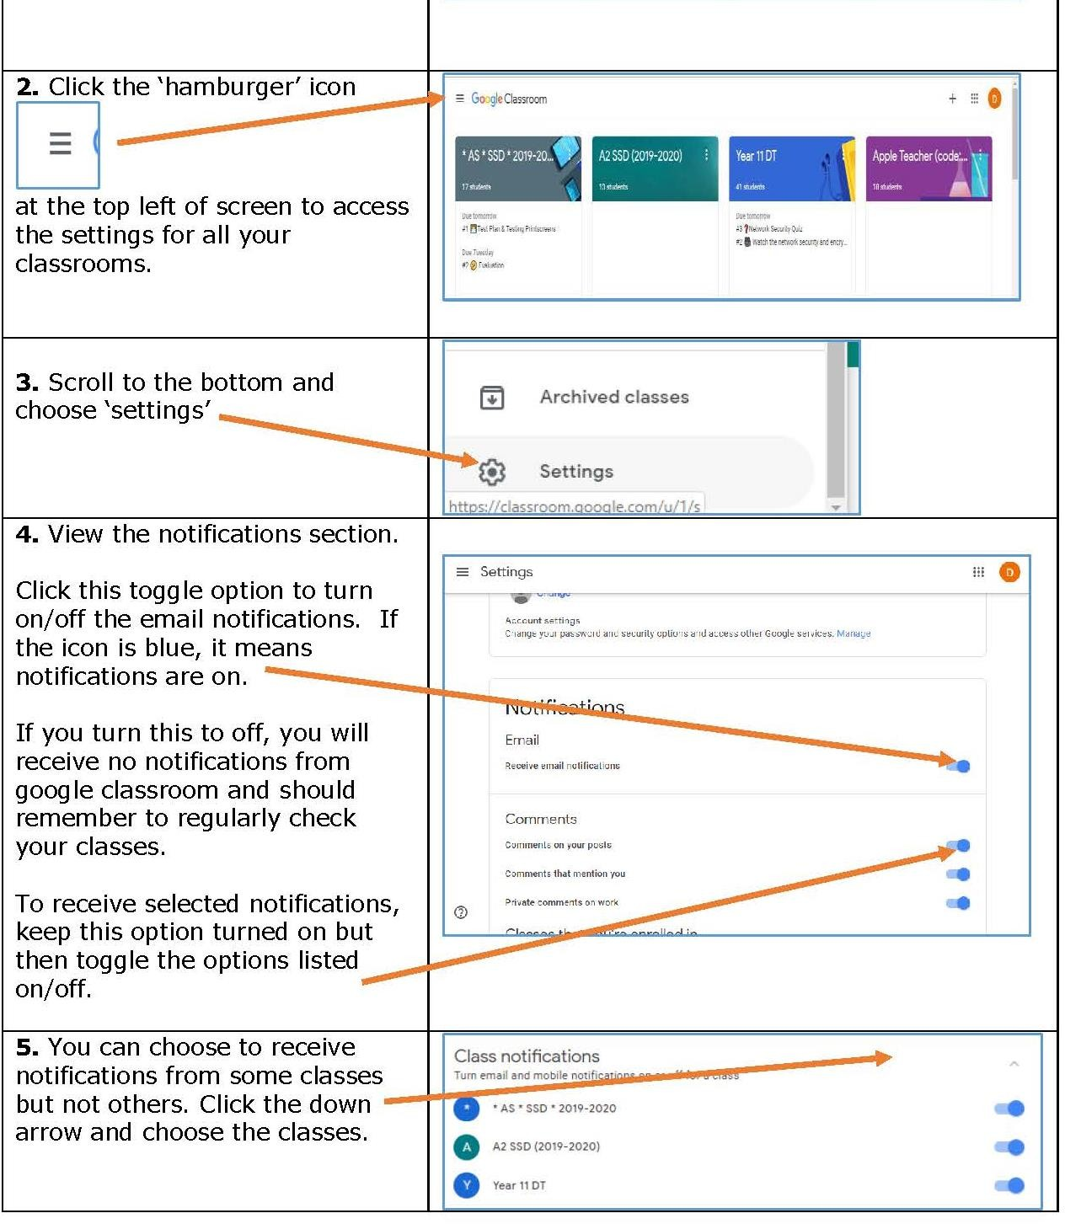
- Load the Google Classroom app
Click on the icon below

School email on mobile phone
MOBILE VERSION

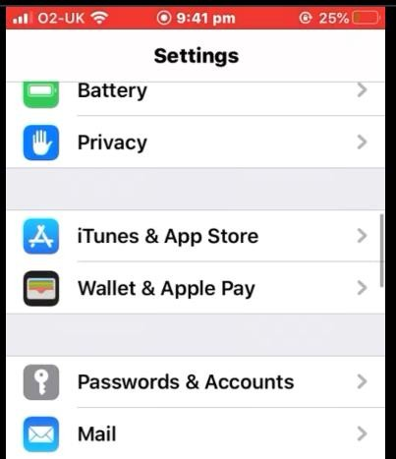
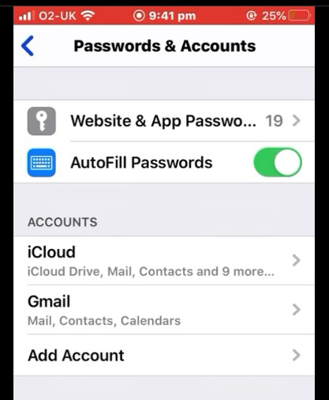
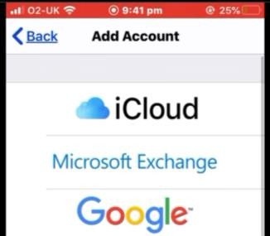
These steps are for an iPhone. Android will be simila
3. Enter your Email and Password

And click next
2.

Choose Google /Gmail
Then Add account.
Choose Password and
accounts.
1. Go to the settings of
your phone.

