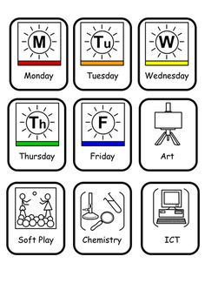 | 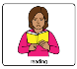  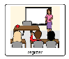 | 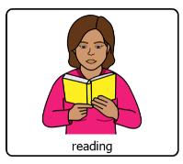 |  | 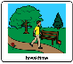 | 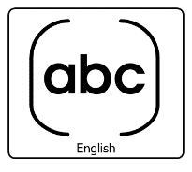 |  |  |  | 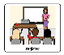 | 
 | 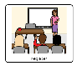 |  |  |  |  |  |  |  |  | Mr Gauden
 | 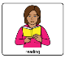  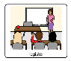 | 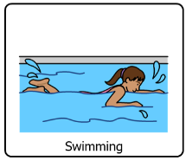  Miss Barry |  |  |  |  |  |  |  | Miss Beed | 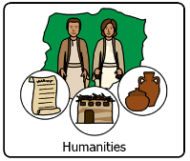  Mr Wood
 |  | Miss Beed | 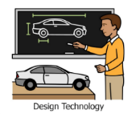  Miss Livingston |  | Miss Cant |   Miss Foga |  |  |  | 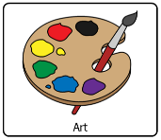  Miss Moreton | Mr Gauden
 | 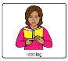 | 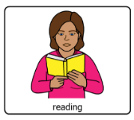 |  |  |  |  |  |  |  | 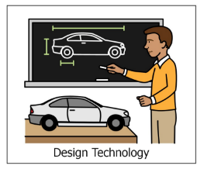 | Mr Gauden

