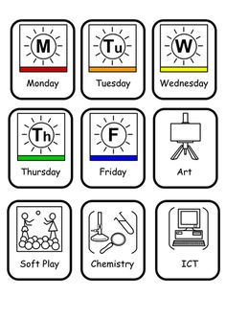 | 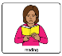  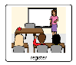 | 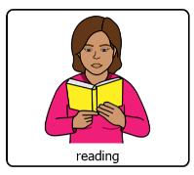 |  |  |  | 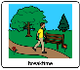 | 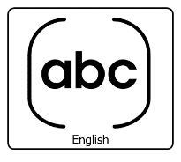 |  |  |  |  | 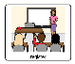 | 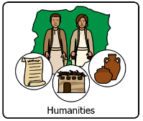
 | 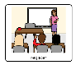 |  |  |  |  |  |  |  |  |  |  |  | 
 | 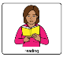  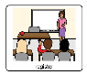 |  | Mr Gauden |  |  |  |  | 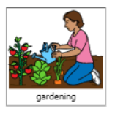
 |  | Miss Beed |  |   Miss Livingston |  |  | Mr Gauden |  | Miss Cant |  |  |  | 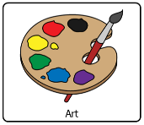  Miss Moreton
 | 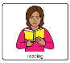 | 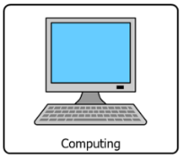  Mrs Ambrose |  |  |  |  |   Miss Cant |  |  |  |  |  | Miss Moreton  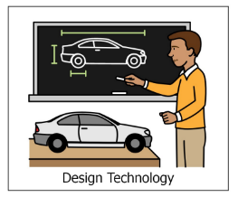   | Miss Beed  